# Table of Contents

Table of Contents 1

Section 14: Deployment & Email 2

14.1 Database Initializer 2

14.2 Email Service 5

14.2.1 Create SendGrid Account 5

14.2.2 SendGrid Sender Authentication and API Key 10

14.2.3 Configure Email Service 16

14.2.4 Use Email Service 18

14.3 Azure Deployment 21

14.3.1 Create Azure SQL Server and Database 21

14.3.2 Set Server Firewall 28

14.3.3 Get Connection String for Database 29

14.3.4 Downgrade to ASP.NET Core Version 7 31

14.3.5 Azure Production Deployment 33

14.3.6 Replace Hardcoded URL 40

# Section 14: Deployment & Email

## 14.1 Database Initializer

Before we place this application in production, we need to think that how roles and the very first Admin user will be created. Previous we insert roles manually inside action method OnGetAsync of page model of Register page which is not a correct way.

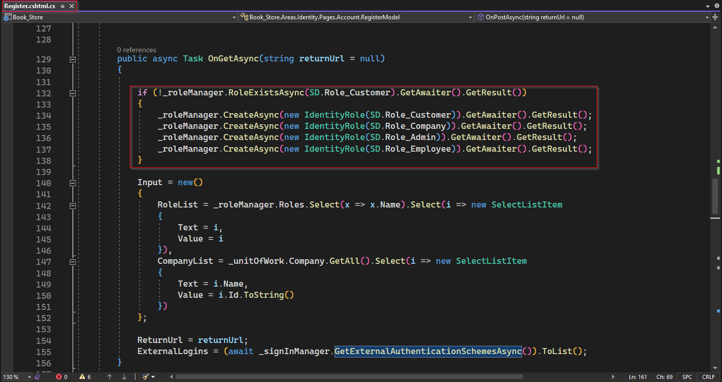

Let’s explore correct and more professional way to seed the initial data to database.

First Create a folder "DbInitializer" inside DataAccess project. And inside the folder "DbInitializer" create an interface with name "IDbInitializer.cs" with a void method Initializer();

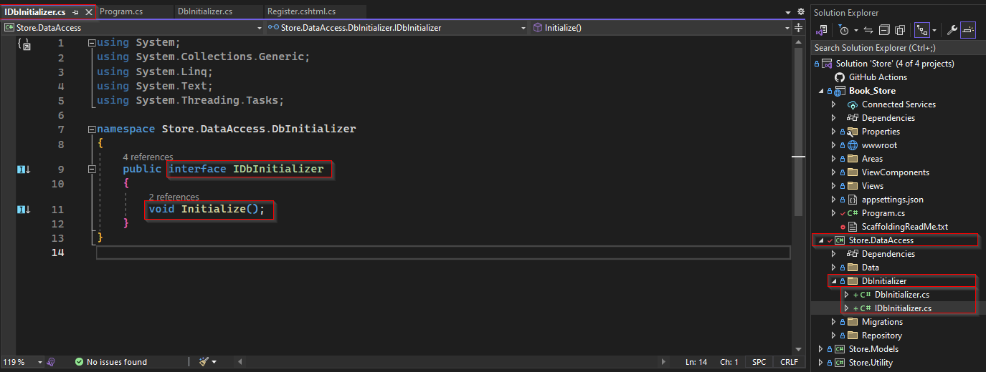

Now create a class "DbInitializer.cs" that inherit "IDbInitializer.cs". Inside this under implementation of Initializer(). We perform following three tasks

* Check for pending migration if any found push it to update database.
* Create roles if they are not created.
* Create the very first user with Admin role.

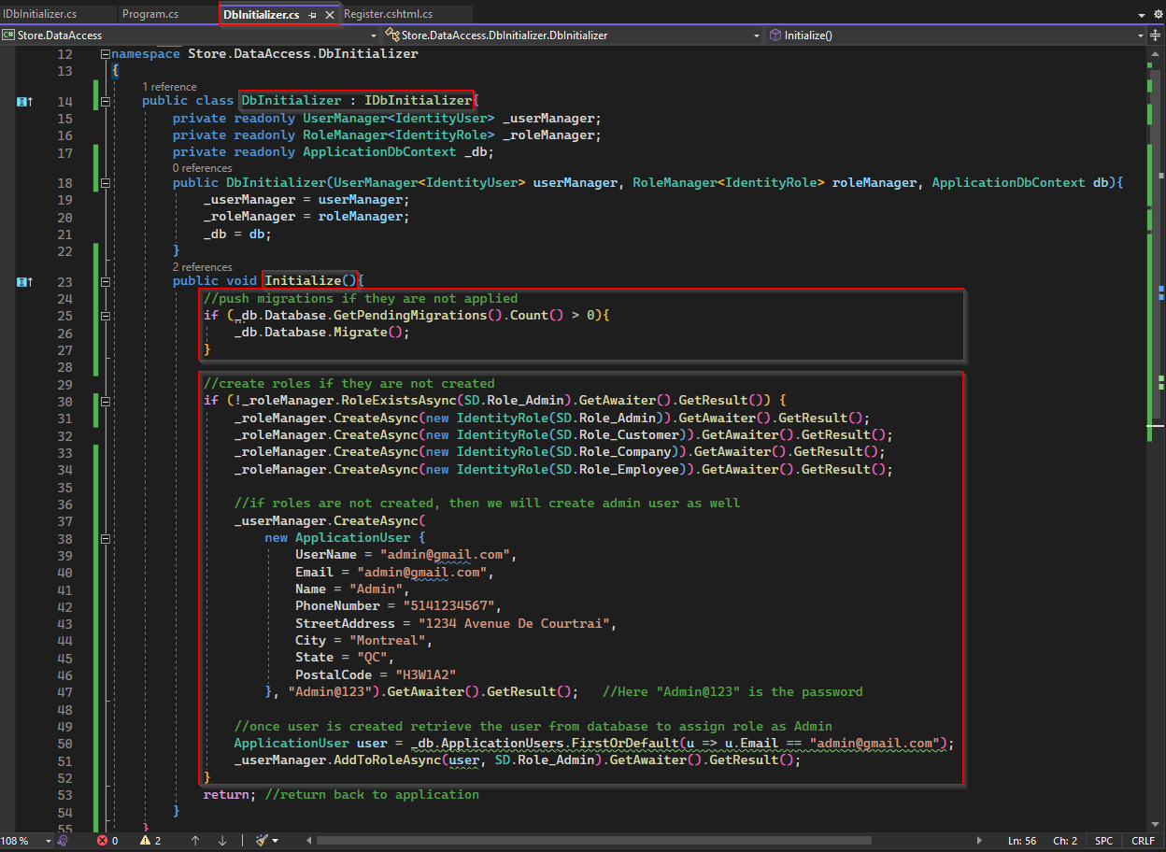

Then inside Program.cs configure Service for interface IDbInitilizer. And add it on pipeline so each time application run it will implement DbInitializer.

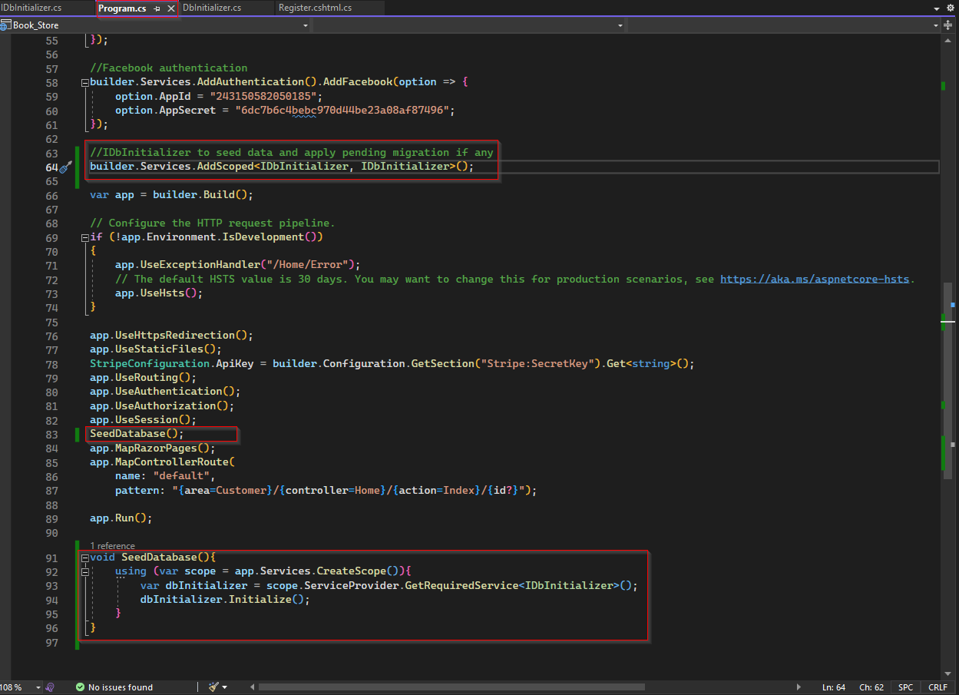

Let’s perform a test if everything working correctly. For this inside appsetting.json let’s modify the database name as TestDbSeed and run application. If everything worked as expected it should create database and seed roles data, Admin user, all migrations that are inside Migration folder.

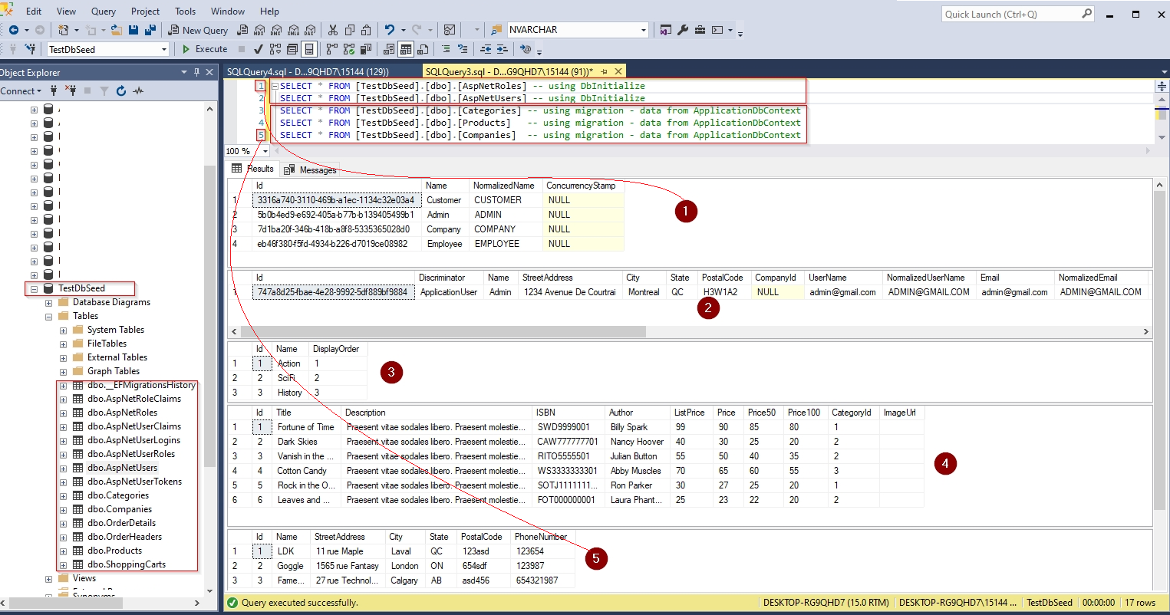

## 14.2 Email Service

### 14.2.1 Create SendGrid Account

Using SendGrid we can send multiple emails without having an email server. It provides two ways to send emails.

* using SMTP relay
* using Web API

In this section we are going to use its Web API and for that we first need to have an account in SendGrid, where we create and set sender email, create an API Key, and using that API Key we can configure our email service in our application. But to use SendGrid for email, you must have a domain email, the personal email like Gmail, Yahoo etc. will not work.

To open account in SendGrid let go to its website typing sendgrid.com in browser.

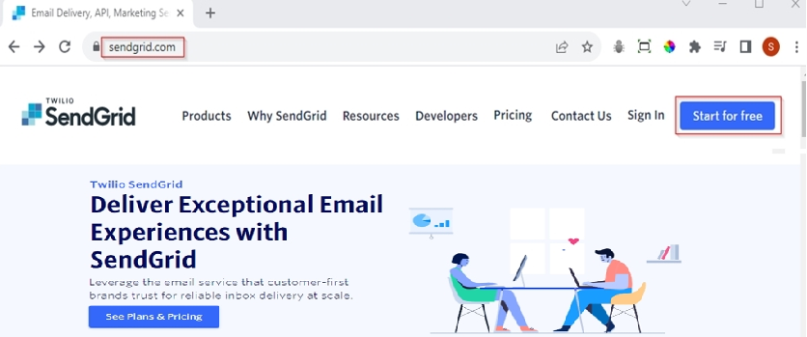

Then Click on "Start for free" button, will redirect to its signup page as below.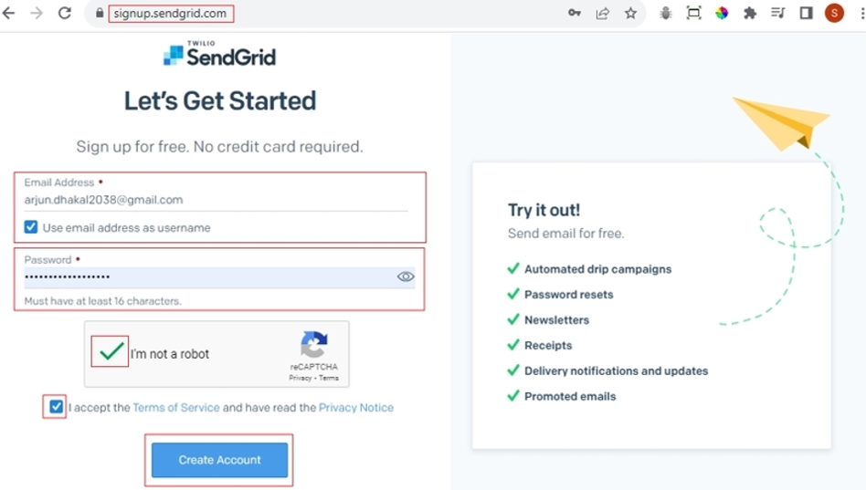

To sign up, provide an email address and password, then check the checkboxes for "I’m not a robot" and "I accept the Terms of Service and have read the Privacy Notice". Finally click "Create Account", it will take you to following page.

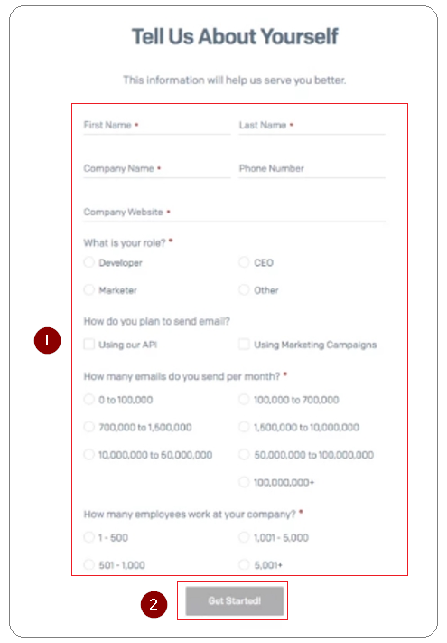

Once you provide values to all above fields, it will ask to set Two-Factor Authentication(2FA) sending a link to email address used for signup.

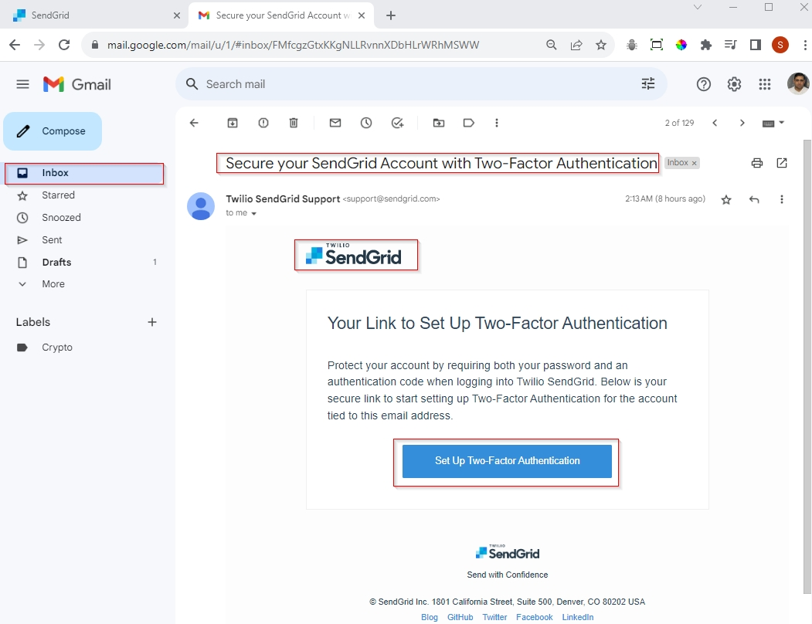

When you click "Set Up Two-Factor Authentication" button, it will redirect you to your SendGrid page as shown below.

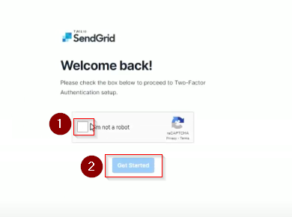

Here check the checkbox "I’m not a robot" and click "Get Started", it will redirect to page to add two factor authentication setup page.

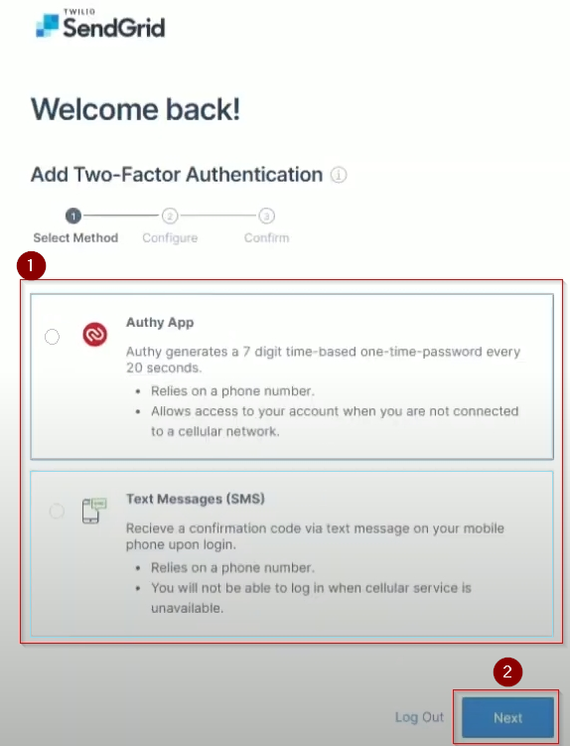

Here, you must choose an authentication option then click Next. If you choose first option, you will need to use a third-party App for OTP and if you choose SMS option you need to provide phone number in form below and hit "Next".

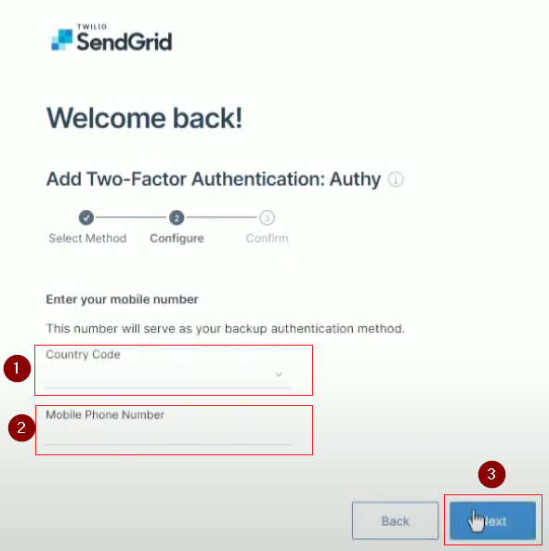

Once you received OTP on your phone, type it to form below then click "Save".

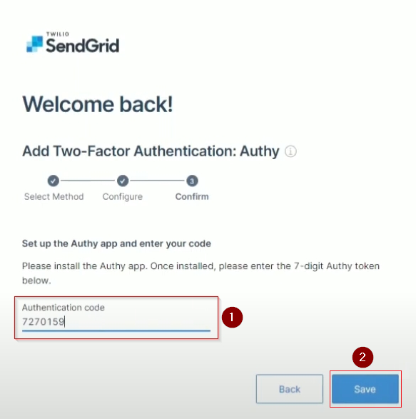

Hence account signup and two factor authentication (2FA) are completed. Click on "Go to login" it will redirect you to login page.

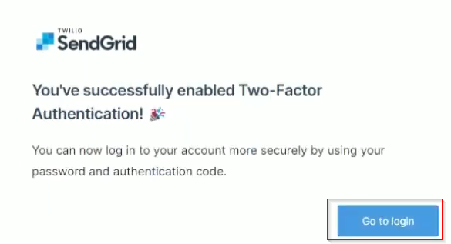

Once you provide your credentials it will send you OTP for 2FA. If you correctly provide OTP, it will take you your SendGrid Dashboard.

### 14.2.2 SendGrid Sender Authentication and API Key

Once you login to you SendGrid Account,

* click on dropdown list on your profile name.
* select Account Details
* Then click on Sender Authentication

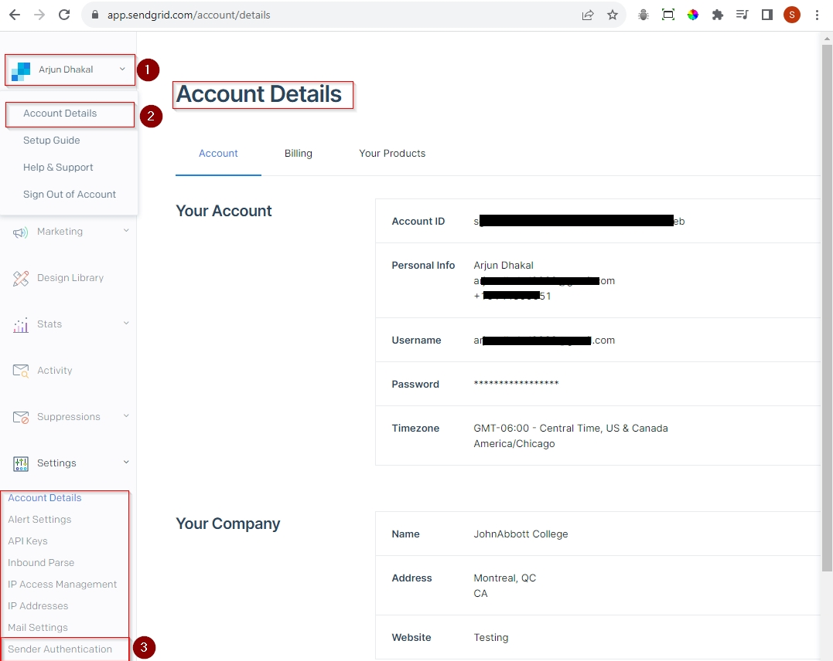

Once you click on "Sender Authentication" it will take you to Sender Authentication page as shown below.

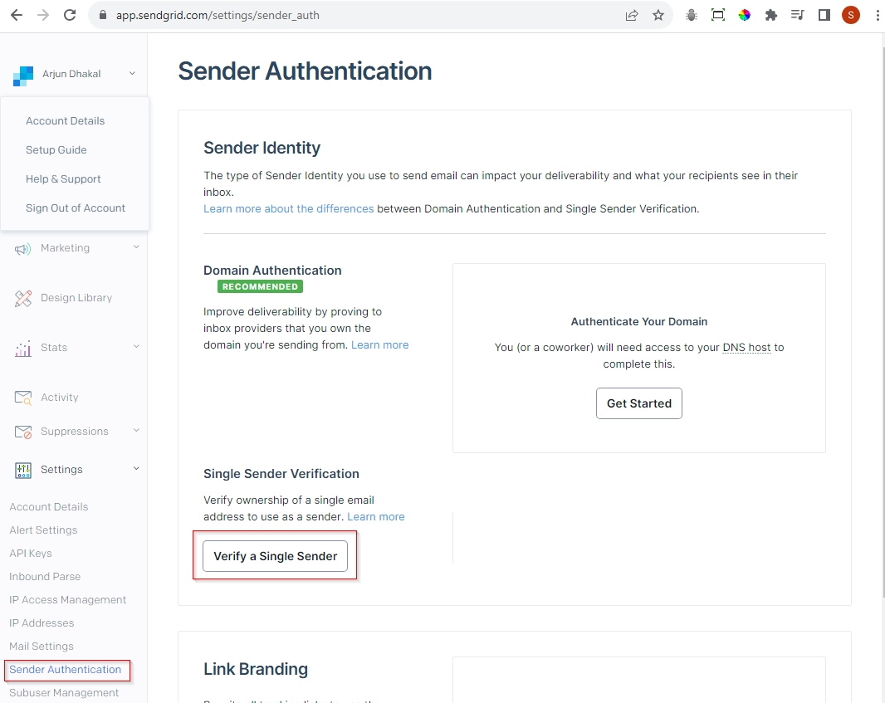

Here Click on "Verify a Single Sender", a Create Sender Form appears as shown below.

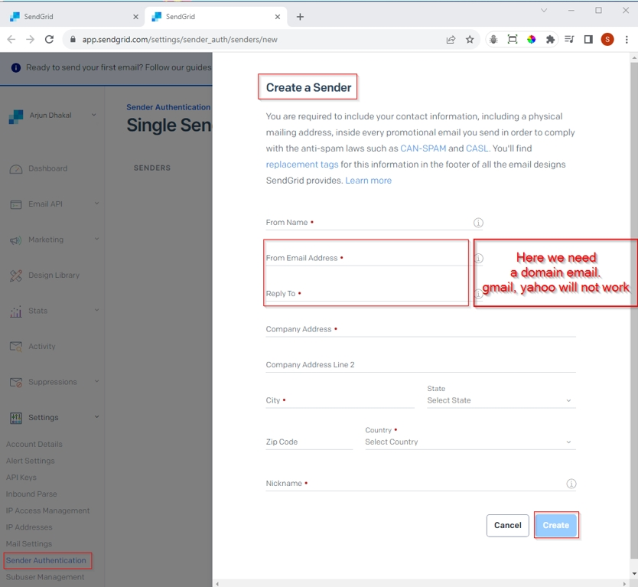

Once you fill up all required input field hit "Create" button. It will sent a verification to the email address you have provided here.

**Note: For the email address used to send email and receive both need to be a domain email. Personal email like Gmail or Yahoo doesn’t work.**

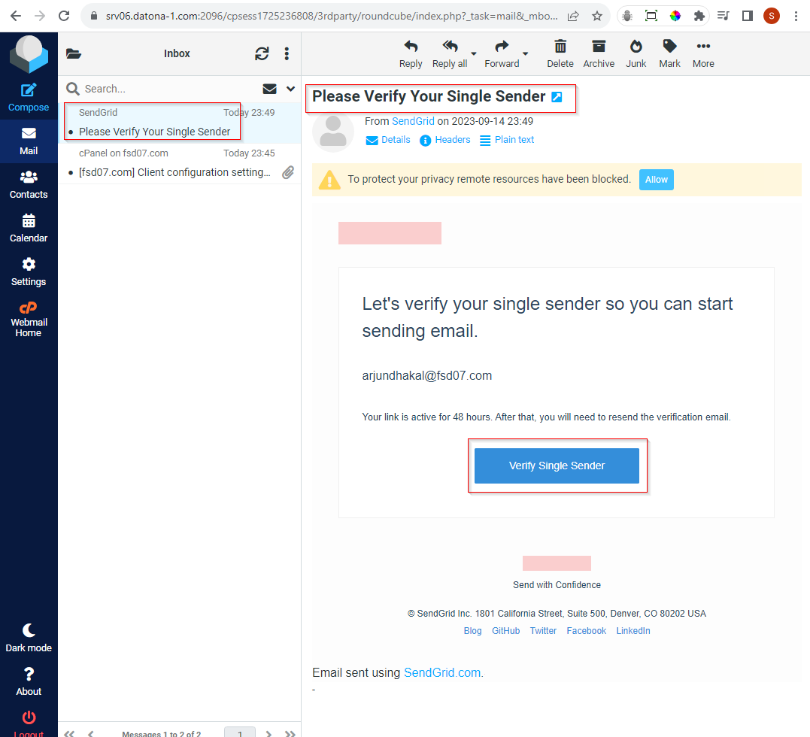

Here you need to click "Verify Single Sender" to verify. Once you successfully verified you can see the status of the sender authentication as below.

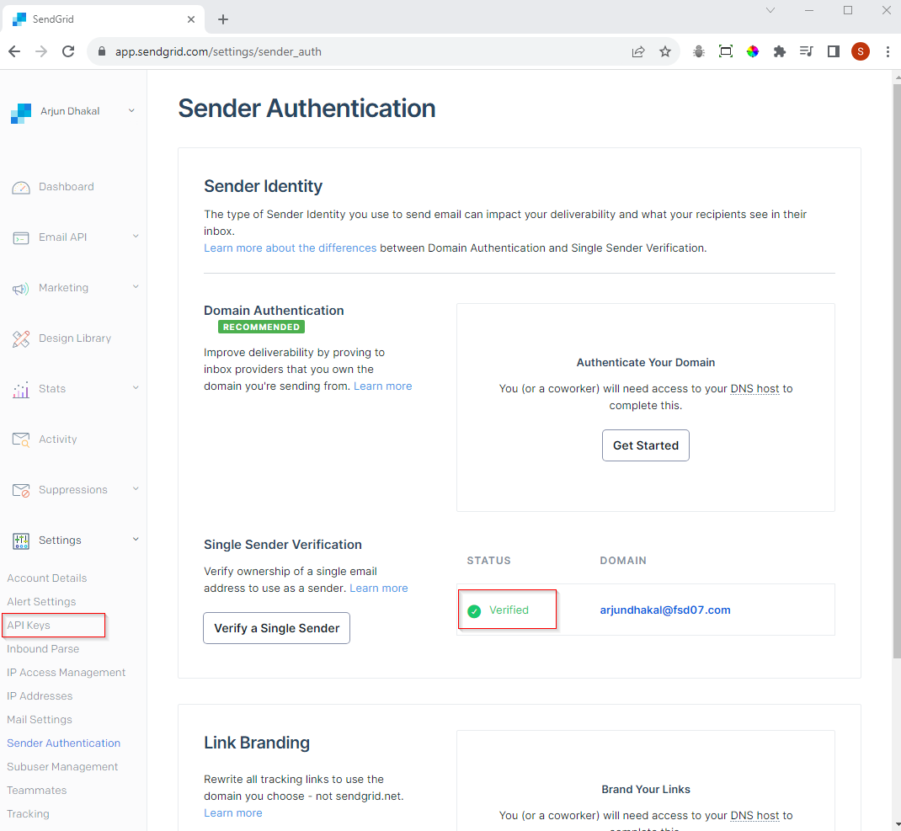

Here status of your domain is verified, and you can create an API Key, for that click on "API Keys", it will redirect to page as given below. Now click on "Create API Key" button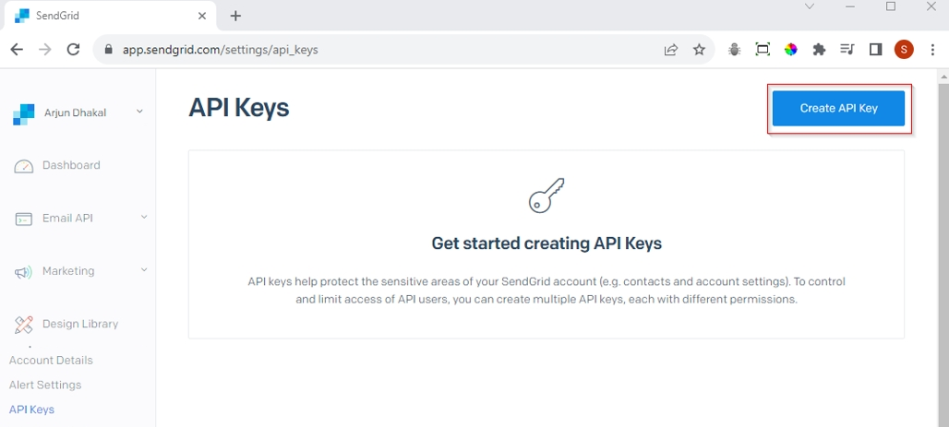

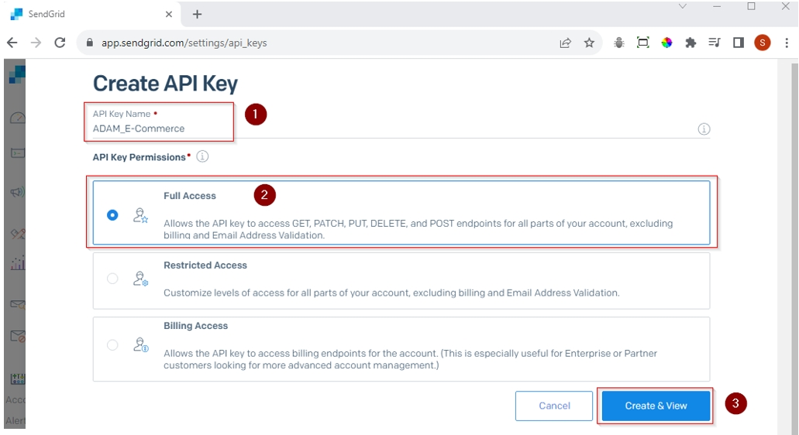

Here, you need to give a name to this API key, select Full Access and click Create & View.

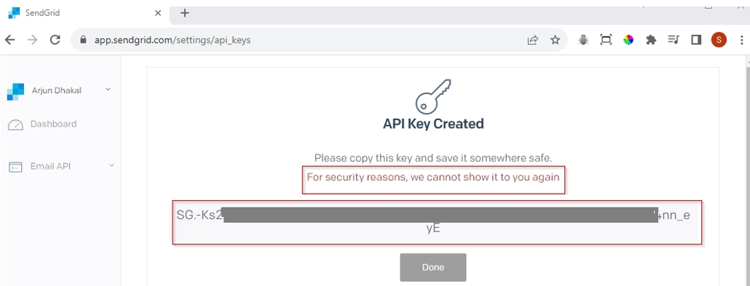

Once API key is created, copy the key, and save in somewhere safe and secure place. Once you close this window you can view it again. We need this key to configure email service in our web application.

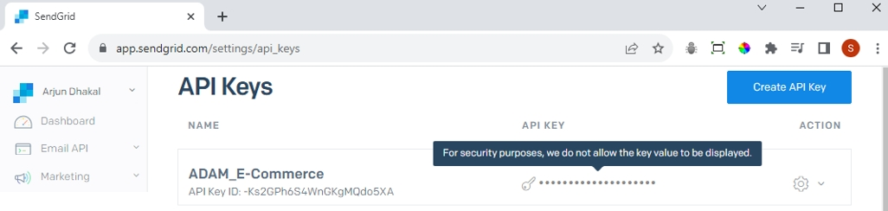

### 14.2.3 Configure Email Service

Now once we have the API key, we can add it on appsetting.json file of our application.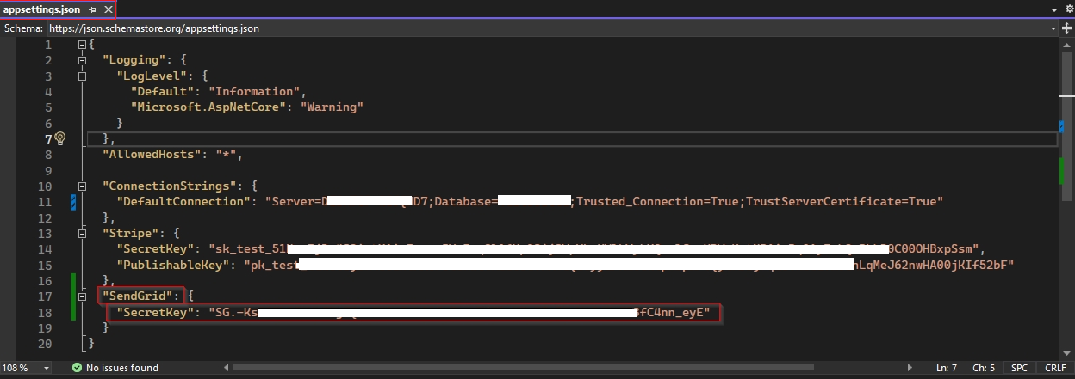

Next, we also need to install package for SendGrid on Utility project.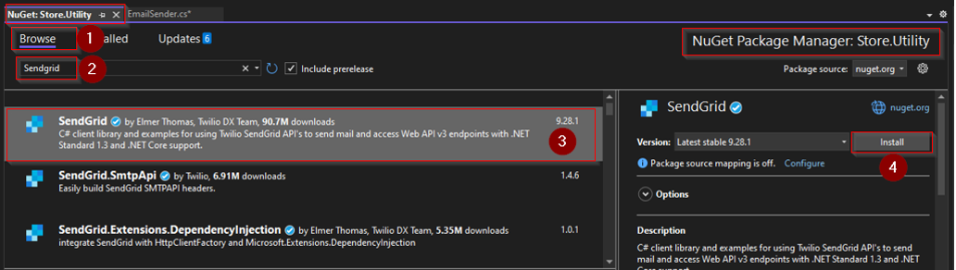

Now, we need to modify EmailSender.cs under Utility. To send email, public class EmailSender must have inherit from base class IEmailSender.

Now, let’s add a property SendGridSecret property of string type and to get SendGridSecret key from appsetting.json we need to inject IConfiguration interface.

The method SendEmailAsync has three parameters which will be supplied while calling this method, but beside those we use SendGrid helpers to grab following parameters.

* Client using SendGrindClient passing SendGridSecret
* From email address using SendGrid EmailAddress function passing domain email address and email header
* To email address using SendGrid EmailAddress function passing input parameter email of type string

Then we can create message using SendGrid.MailHelper.CreateSingleEmail passing above parameter as shown in snippet below. Note for plain text we pass empty space.

Finally we return client.SendEmailAsync passing above message we just created.

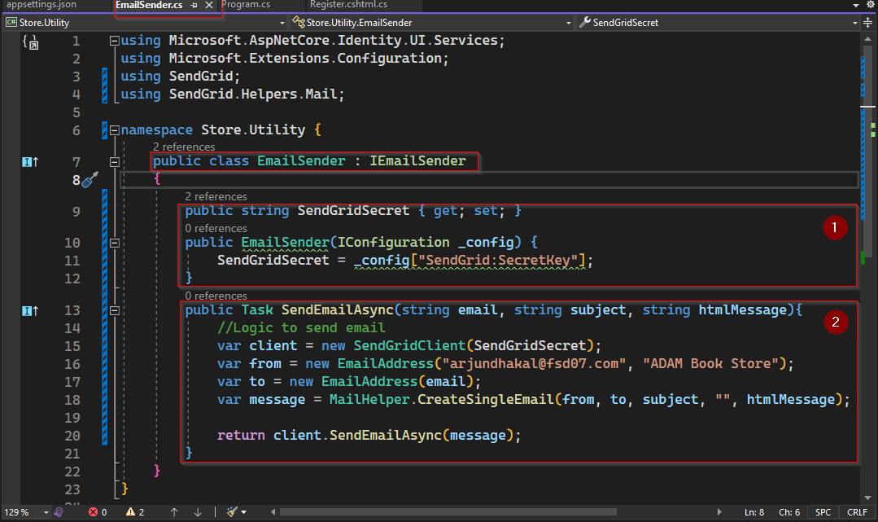

Next go to Program.cs and check if we have injected EmailSender correctly as below.

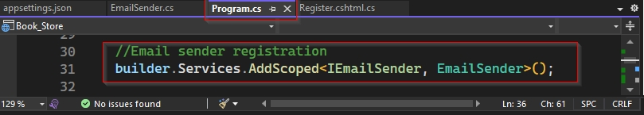

### 14.2.4 Use Email Service

On page model Register.cshtml.cs email service has been added by default on OnPostAsync method. When registration is successful, it automatically sends email to users email address to verify/confirm email address.

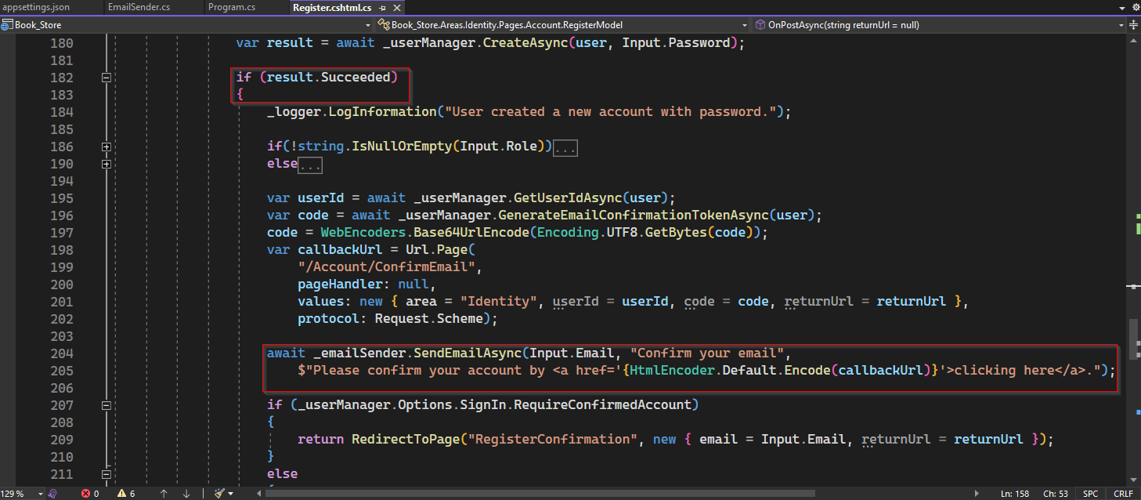

Now to test this functionality, lets register a new account and check if email is actually received.

Once you successfully register, you will receive an email as follows.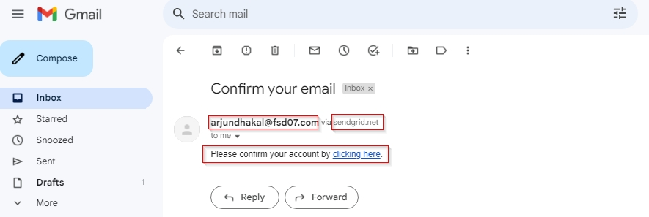

If you click link "clinking here", you will be redirected to the following.

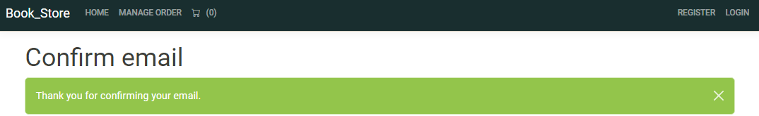

If you check Users table in database, you can see EmailConfirmed is 1 which means true.

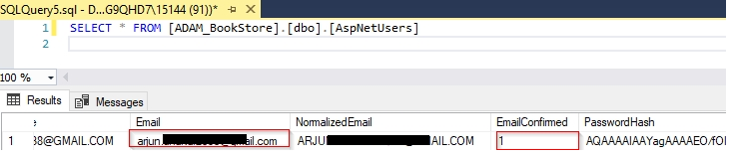

Similarly, we send email to reset password. Note email to reset password will be sent if email has not been verified.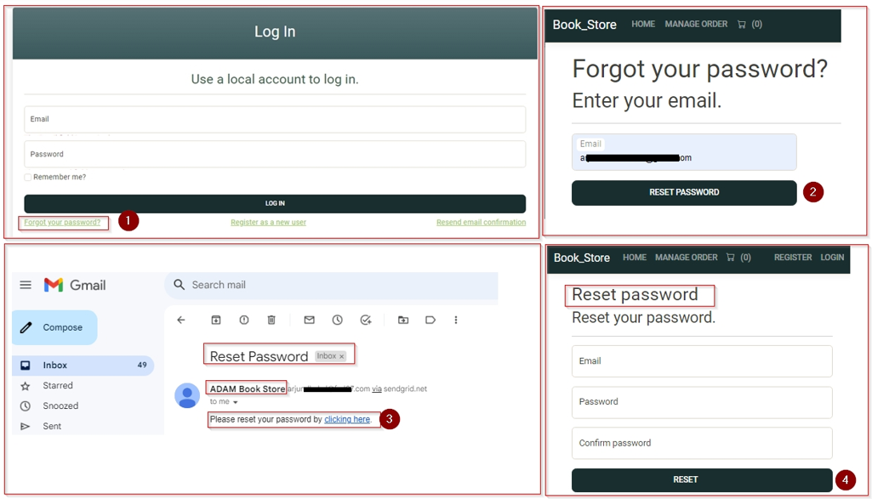

We can also send email notification on creating order by injecting IEmailSender on CartController and adding IEmailSender.EmailSenderAysnc method on OrderConfirmation as follows.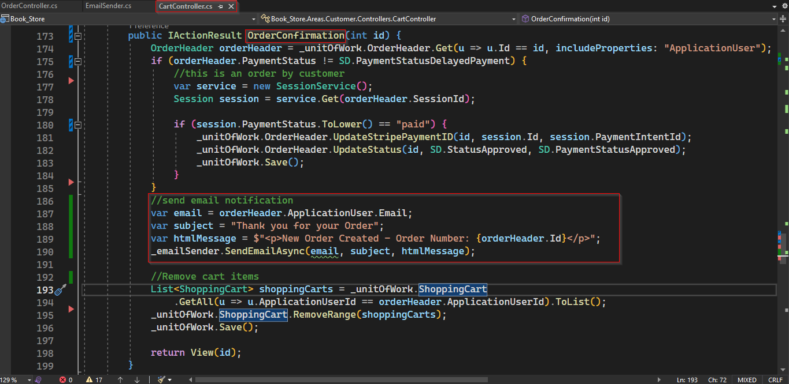Once order is place we get email notification as below.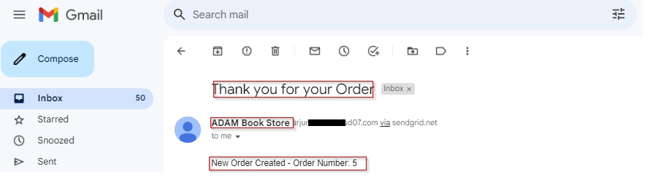

Similarly, we can also send notification once order is shipped.

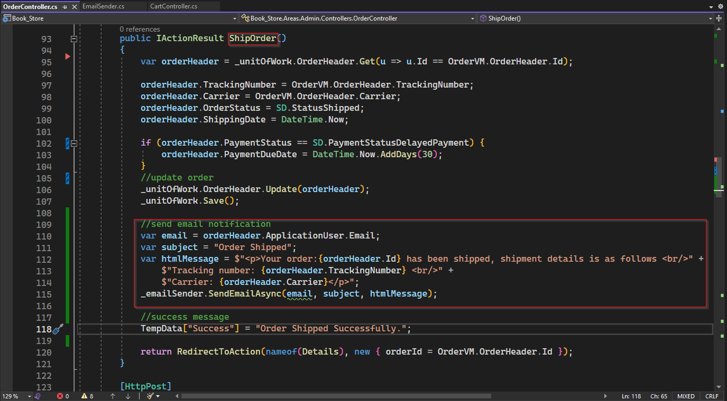

Once order is shipped, customer will receive email notification as follows.

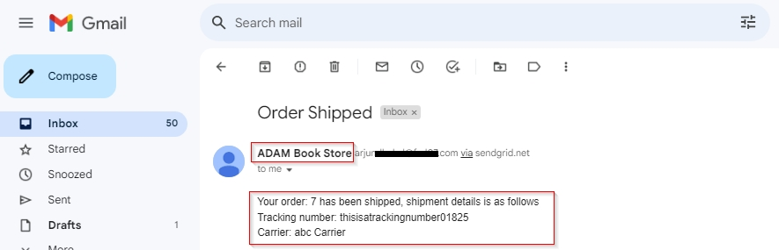

## 14.3 Azure Deployment

To deploy app in Azure we first need to have an account and active subscription on Microsoft Azure. Once can create an account with using email address which will also have USD 200 initial balance.

### 14.3.1 Create Azure SQL Server and Database

To create SQL Database on Azure, login to your account, then you will get following home page.

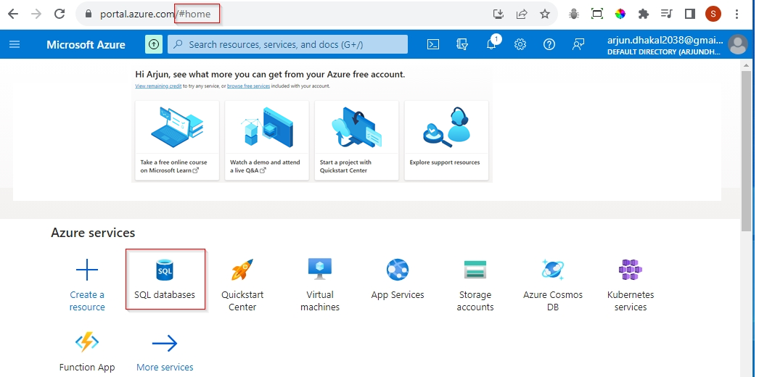

Now, click on "SQL databases" under Azure services.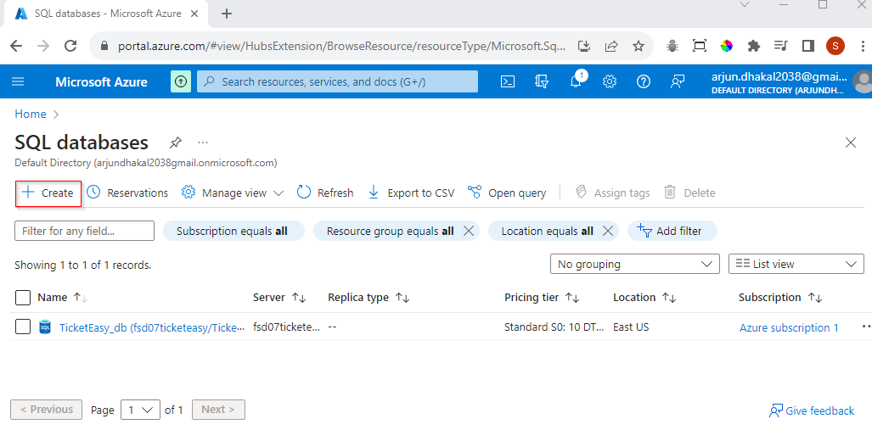

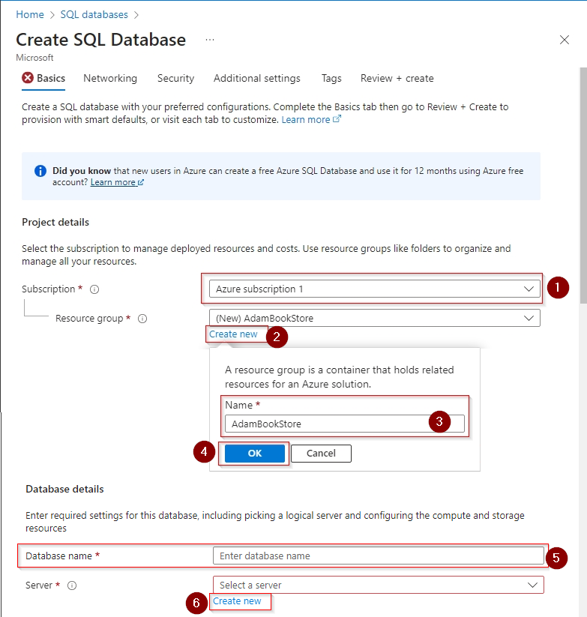

Steps to create SQL Database

* First you have to select your subscription
* Select resource group from dropdown list or click on "Create new", provide some sensible name then hit OK.
* Give database a meaning full name.
* Create a server, for this click on "Create new" the following window appear.

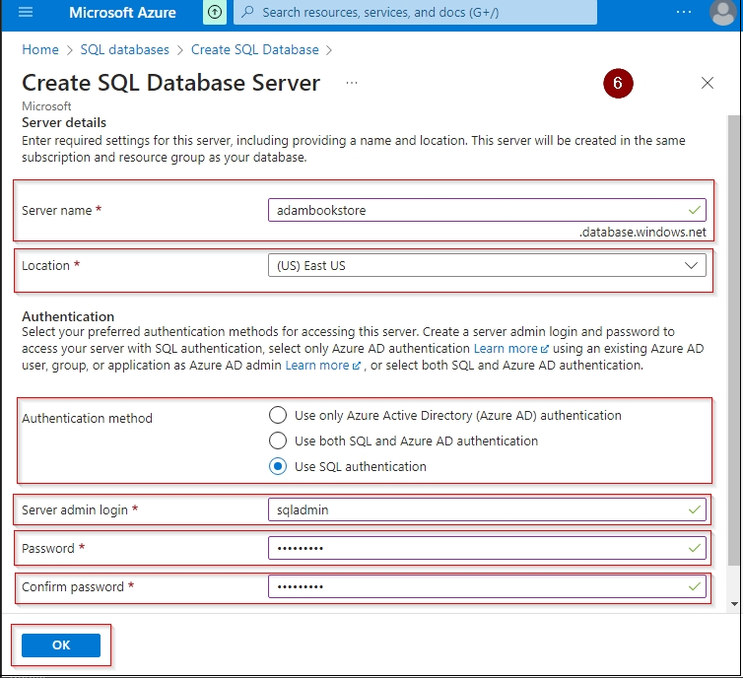

* Give the unique name for server.
* Select location from dropdown list.
* For authentication we can choose SQL authentication for we need to set user Id and password.
* Then finally click OK to create new server.

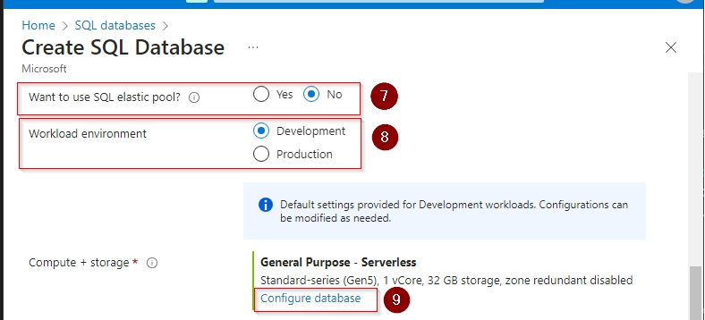

* For choice of SQL elastic pool, you can select "No".
* Workload environment – Development
* Now click on "Configure database" and it will bring you to following page.

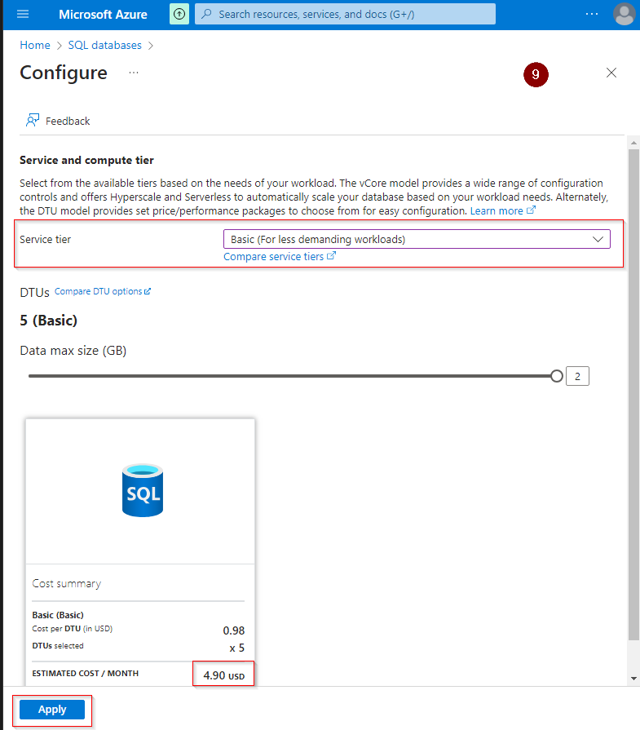

Here you can choose "Basic" Service tier which cost around 4.90 USD per month, then click "Apply" then it redirect you to review page.

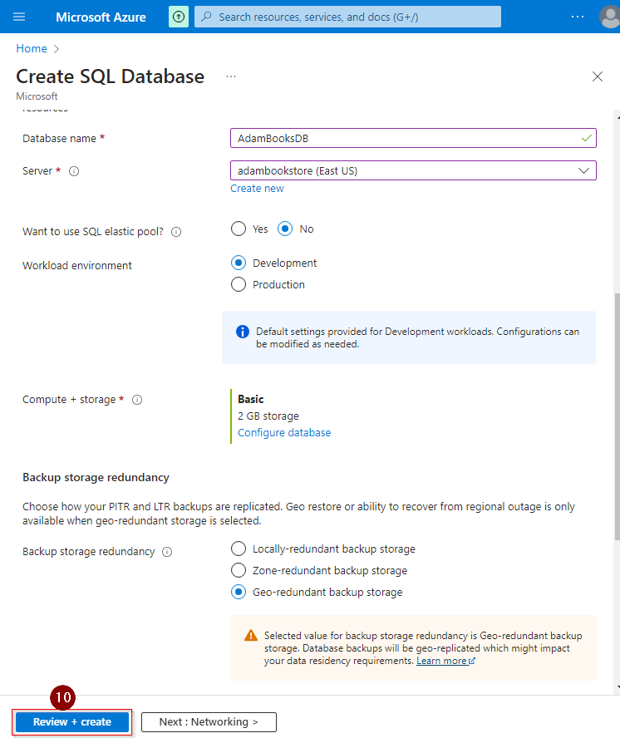

Now once everything seem OK, click on "Review + create", the you will see the final confirmation page to create SQL database.

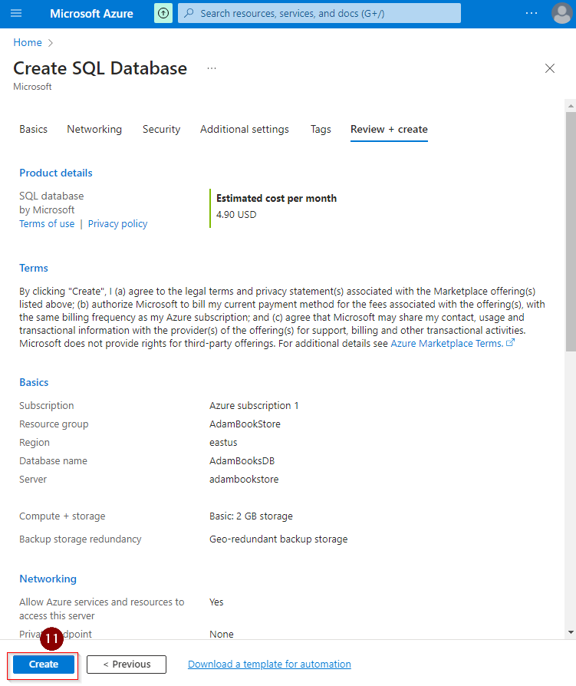

Now, once you hit "Create" button, it will start process to create database.

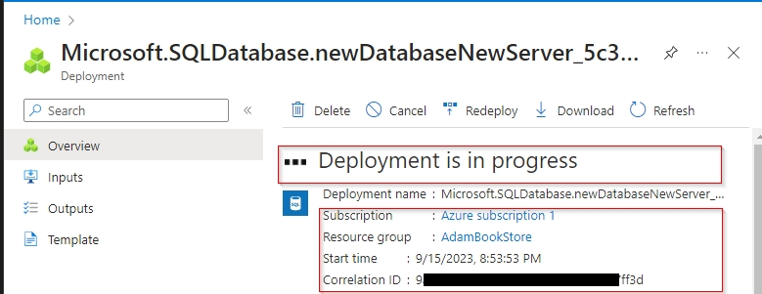

This process may take few minutes and once complete you can see completion message.

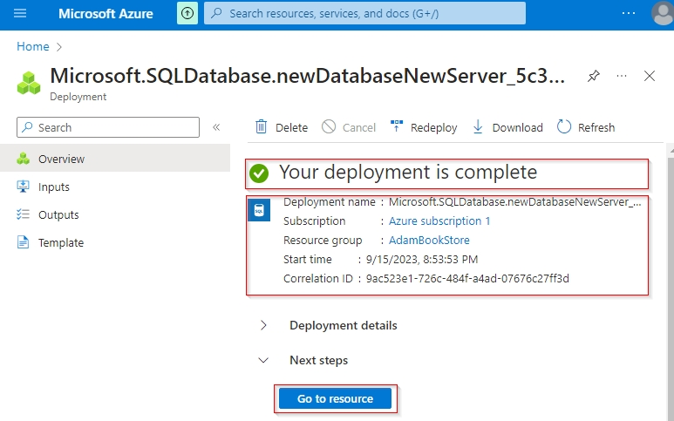

Now click on "Go to resource".

### 14.3.2 Set Server Firewall

Azure Firewall is a managed cloud-based network security service that protects your Azure Virtual Network resources. Azure Firewall decrypts outbound traffic performs required security checks, and then encrypts the traffic to the destination. It works in conjunction with URL filtering and web categories by letting administrators allow or deny user access to web page.

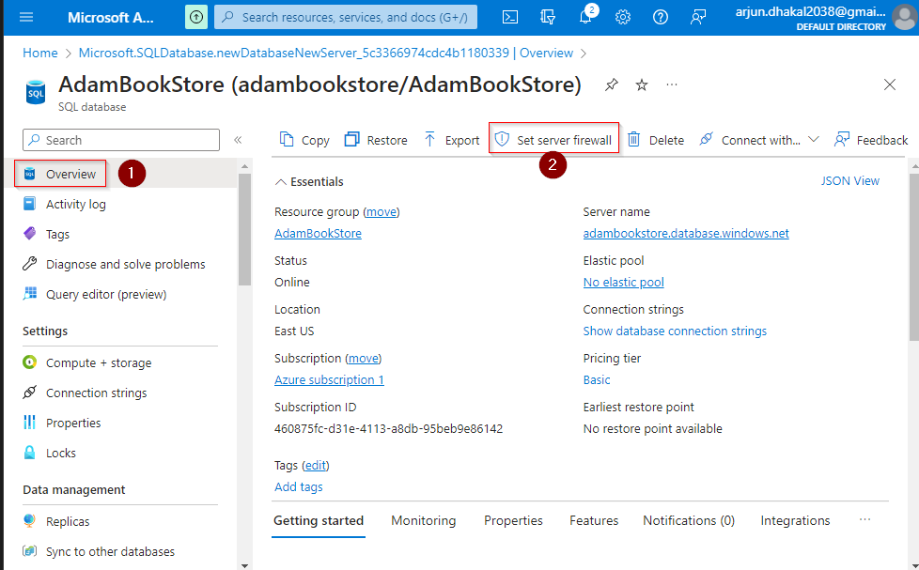

To set server firewall, go to Overview page of the database then click on "Set Server Firewall".

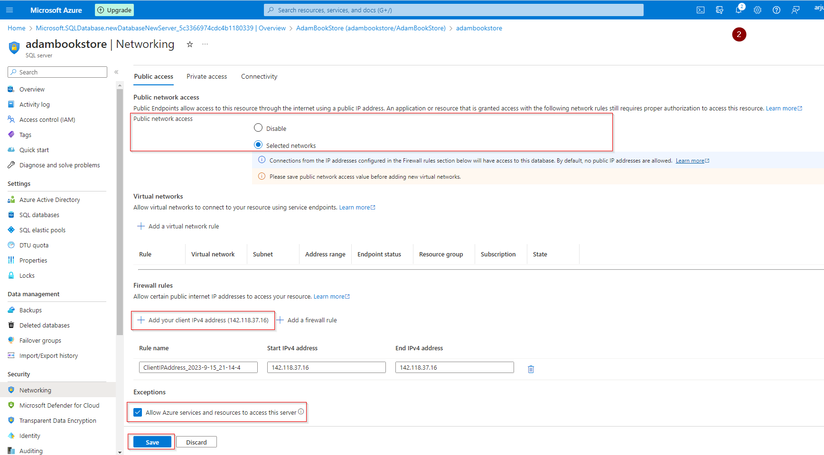

* For public network access – select "selected networks".
* Click on "Add your client IPv4 address" then it will add IP address of current device.
* To allow to communicate to server, "Allow Azure serves and resource to access this serve" must be selected.
* Finally click save.

### 14.3.3 Get Connection String for Database

Now to go overview page of resource group.

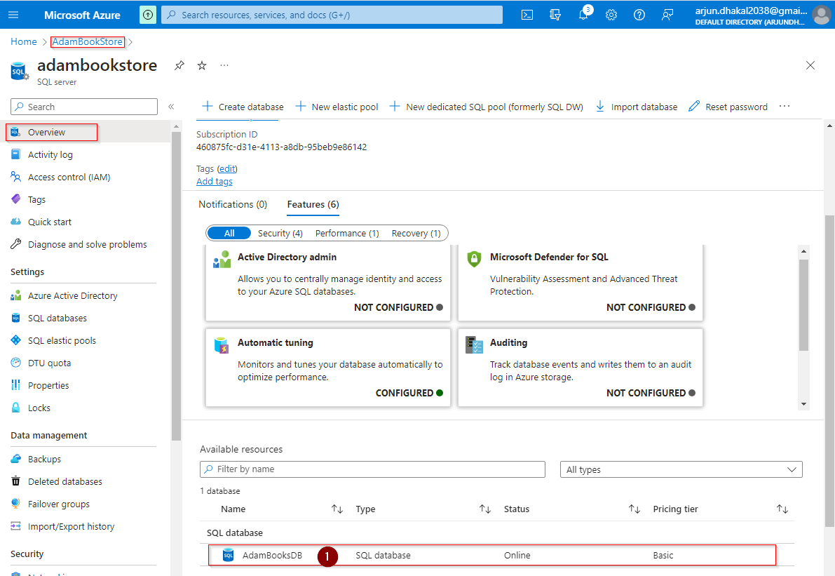Under available resources section of above page and click anywhere on row with database description. It

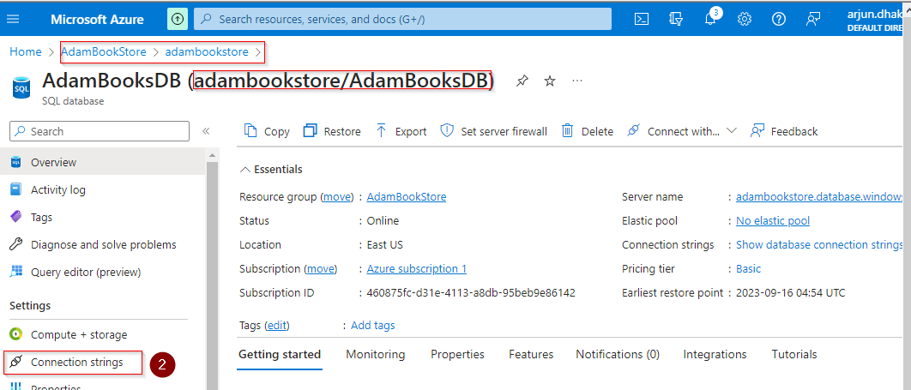

Once click on "Connection string" you can view the connection keys.

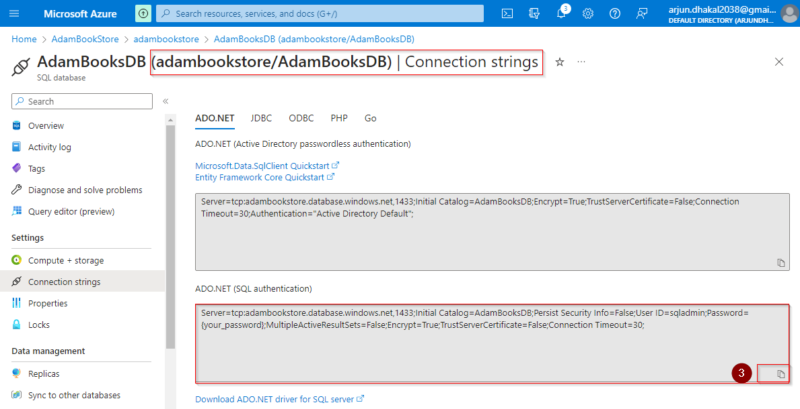

Copy the connection string, for ADO.NET (SQL Authentication) and you can added it appsetting.json file. This connection string will be used to connect with the database and deploy application.

Server=tcp:adambookstore.database.windows.net,1433;Initial Catalog=AdamBooksDB;Persist Security Info=False;User ID=sqladmin;Password={your_password};MultipleActiveResultSets=False;Encrypt=True;TrustServerCertificate=False;Connection Timeout=30;

### 14.3.4 Downgrade to ASP.NET Core Version 7

Since we are using ASP.NET Core Version 8 preview, to avoid any issue during deployment in Azure, let download to version 7. For this in all four projects under the solution there should be following two replacement in version

* <TargetFramework>net8.0</TargetFramework> replace by <TargetFramework>net7.0</TargetFramework>
* Version="8.0.0 ………….. " must be replace by Version="7.0.3" for all Microsoft packages.

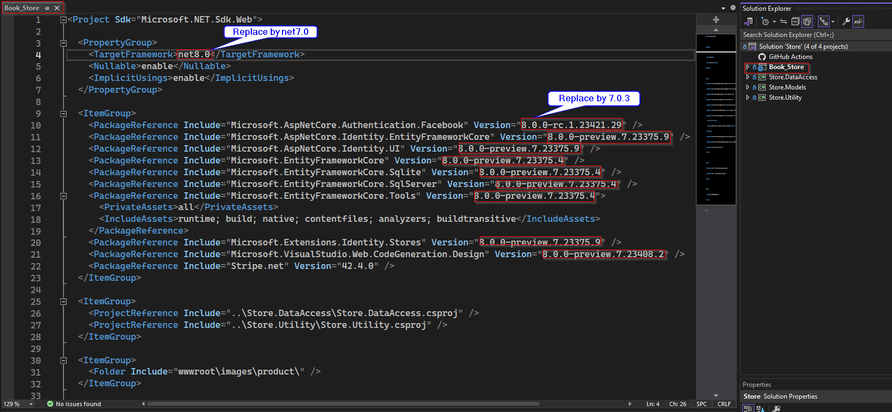

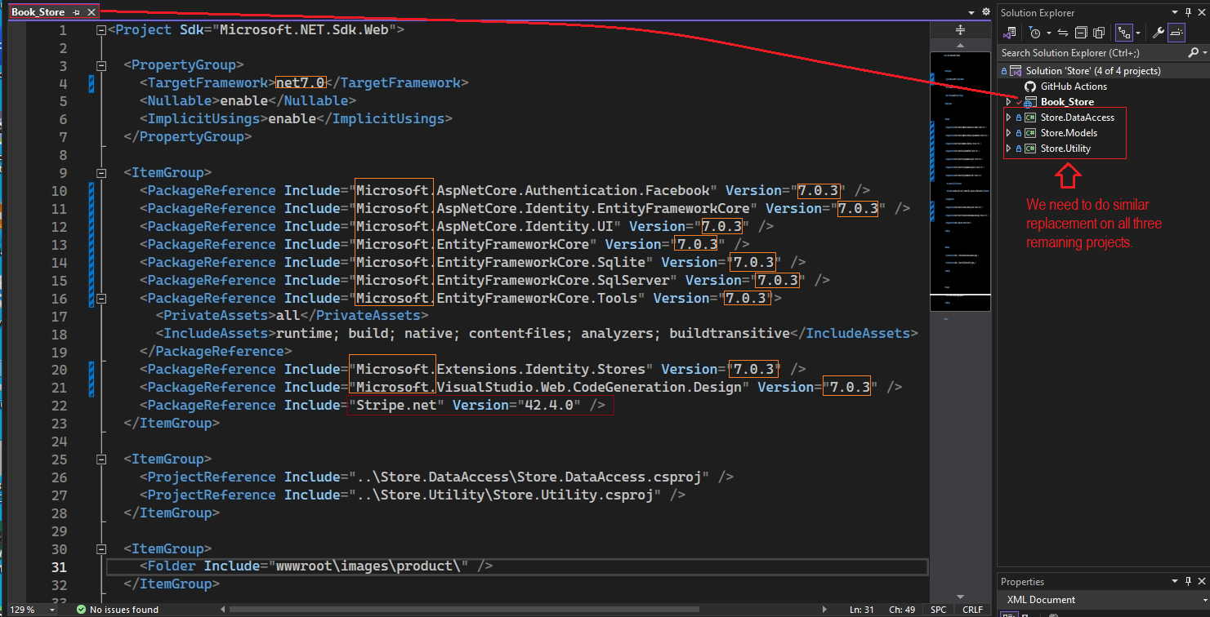

Now we need to do similar replacement on other three projects.

Possible issue with downgrade from ASP.NET Core version 8 to version 7, is if anywhere data type "DateOnly" is used that need is replace by DateTime as "DateOnly" was introduced from version 8 only and it is not available in earlier versions.

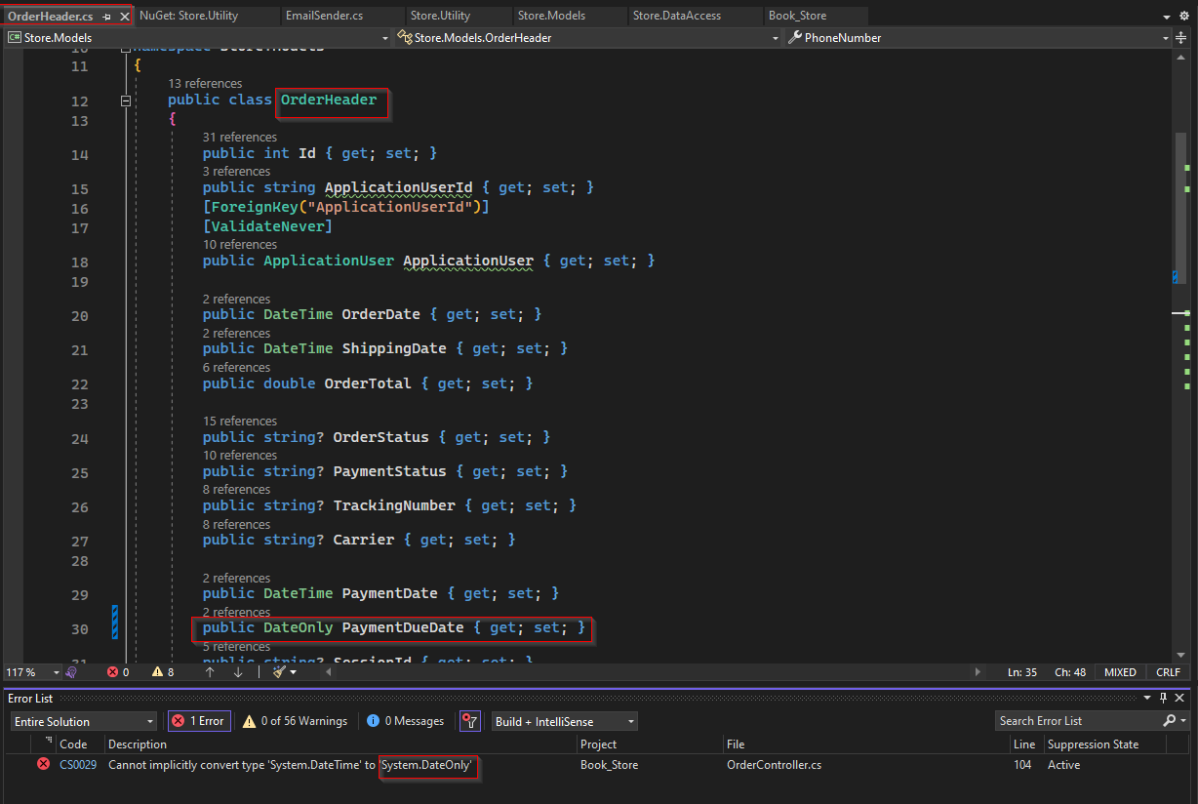

If such issue arises, replace DateOnly must be replace by DateTime.

### 14.3.5 Azure Production Deployment

We already have created the SQL database and SQL Server in the Azure portal.

We need to deploy the app service and that could be done directly from Visual Studio using publish function. But can do that from Azure portal too.

#### 14.3.5.1 Azure Deployment using Azure Portal

For now, let’s deploy from Azure portal. For that go to home page and click on App Service

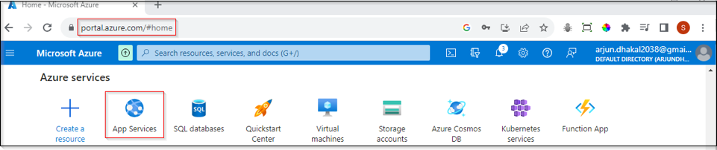

then click on "Create" button and then Web App.

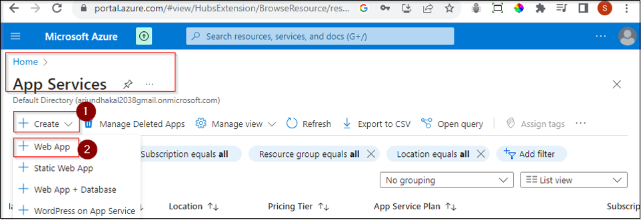

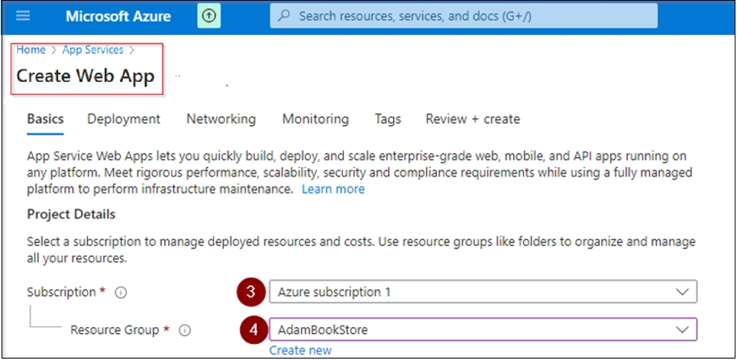

Here select subscription and Resource Group.

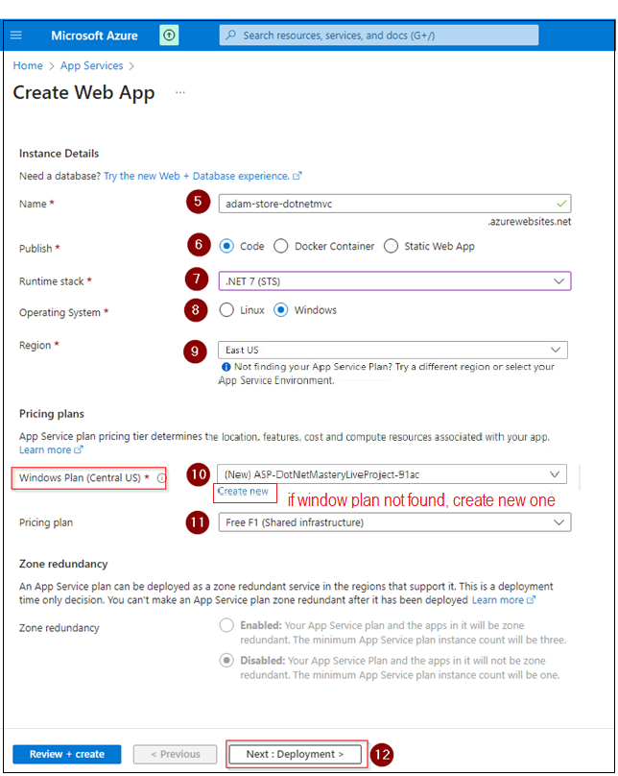

Now give some sensible name for instance. Select code for publish and for runtime stack .NET 7 (STS) and we have downgraded the application to version 7. Then select operative system and region. Then for app service plan select an option from dropdown list. If you didn’t find the App Service plan you are looking for, then change Region. For pricing plan let’s select Free F1. With all this configuration, let hit "Next: Deployment >" it will redirect to page as follows.

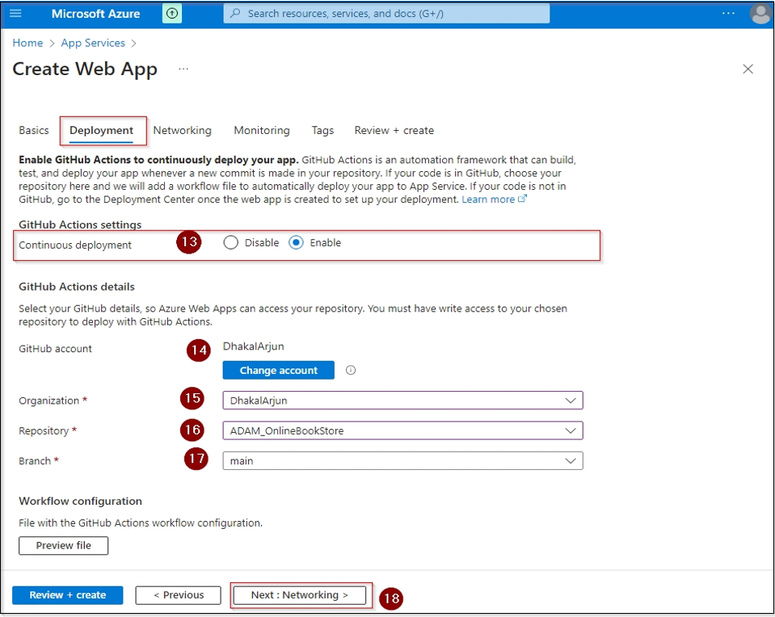

Under deployment,

* for CI/CD – continuous integration and continuous deployment from GitHub, select Enable option.
* In above example Azure is already authorize to my so there is change account button else there will be authorize button. When we click authorize button it redirects to GitHub sign in page, once successful signed in it will be authorized.
* Select Organization from dropdown list.
* Select repository and branch.

Once all selection completed hit Next: Networking >

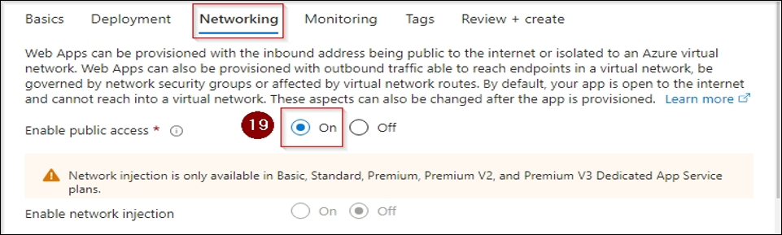

For public access select On then click Next: Monitoring.

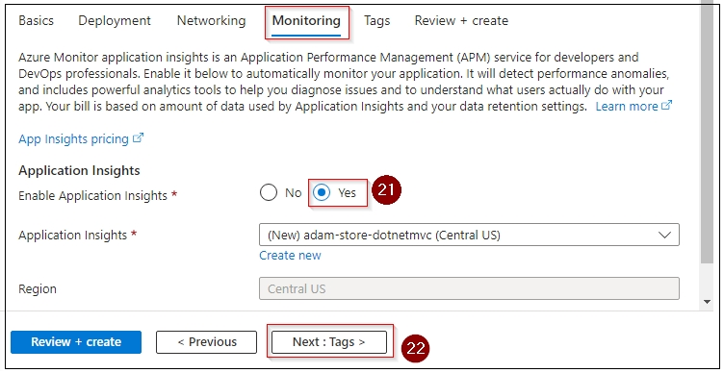

For Monitoring always enable application insights and click Next:Tags>.

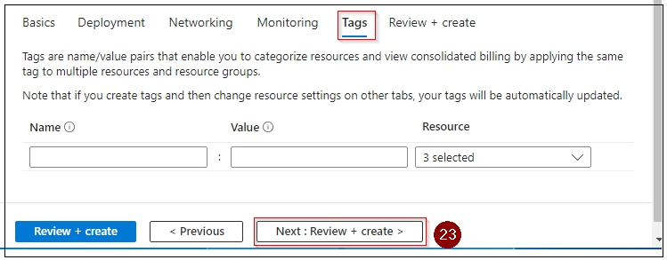

For tags, we can just skip and click Next: Review + Create >

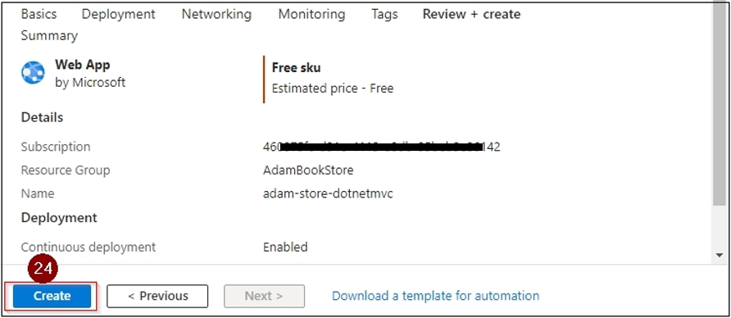

Here check all details, then click Create button. Then it will initialize deployment, upon completing we will get completion message.

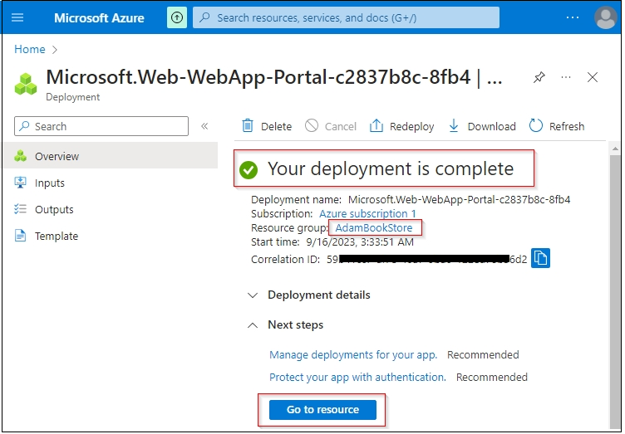

Now go to resource page.

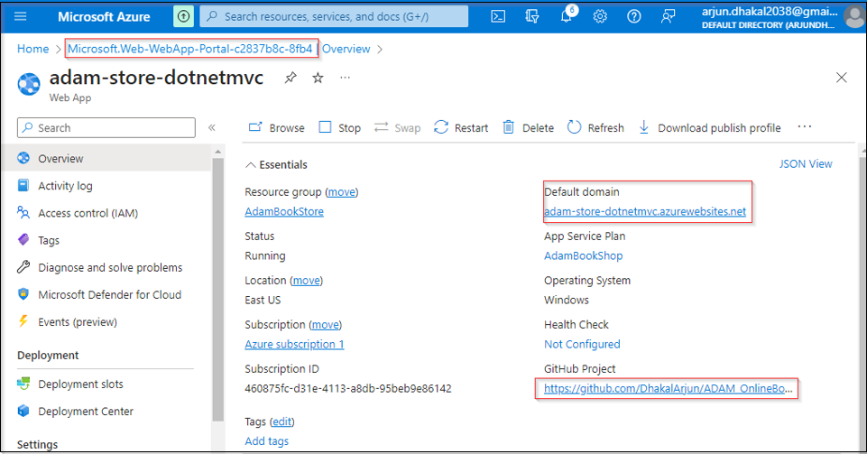

Here, we can find the value of default domain of web application just deployed.

Although deployment is completed, when we try to render to the web application, we will get following error as with the application no database is connected till now.

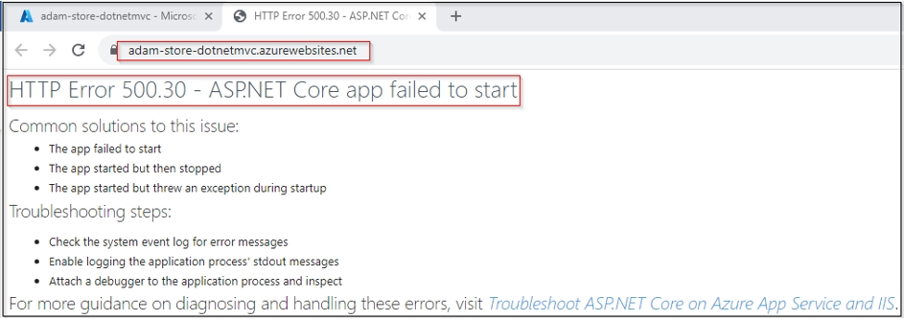

To connect application to Azure SQL database as production database, let add a appsetting.json file to main project and give the name as appsettings.Production.json.

Then copy everything from appsetting.json and replace content of new file just created.

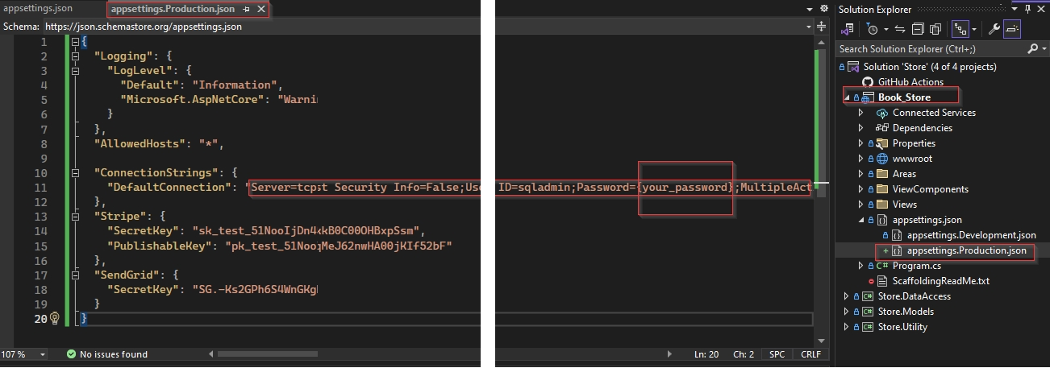

Now go to Azure portal and copy the connection string as describe before and replace the value of DefaultConnection Key. Then in the connection string we need to provide password of Asure SQL database replacing "{your_password}". Then push the change to Github, and due to CI/CD it will trigger our application to redeployed with the change push.

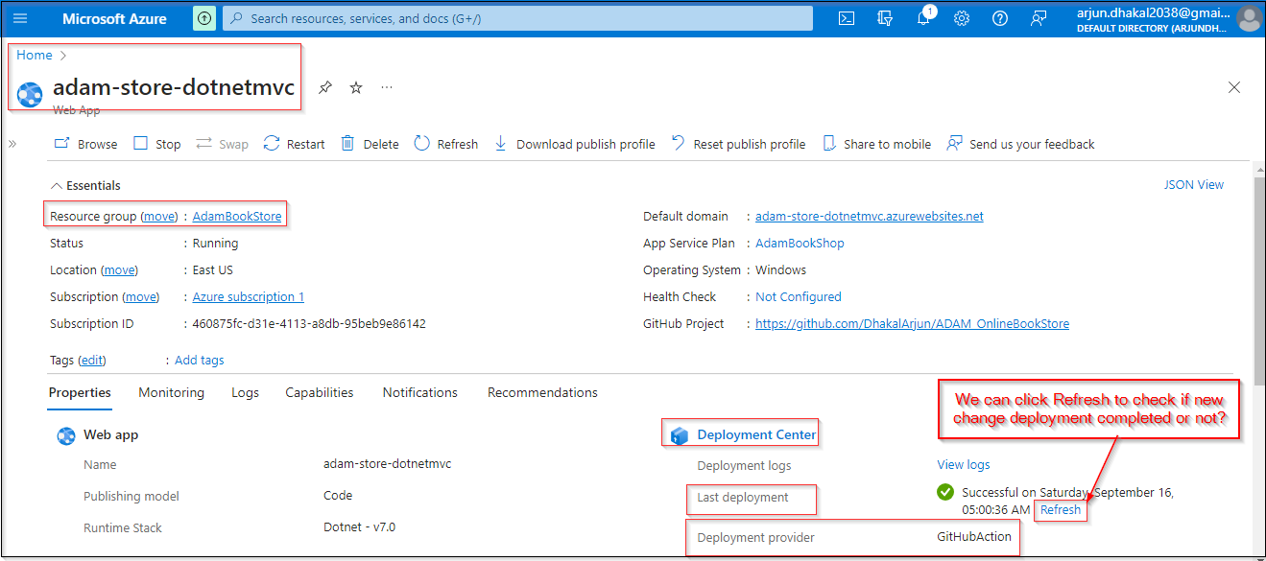

#### 14.3.5.2 Explicitly Set Environment

Once thing to note, although there are multiple appsetting.json file, it automatically detecting which appsetting.json file is to use. But can also explicitly declare the set environment variable. For that go to overview page of Web App and click on Configuration.

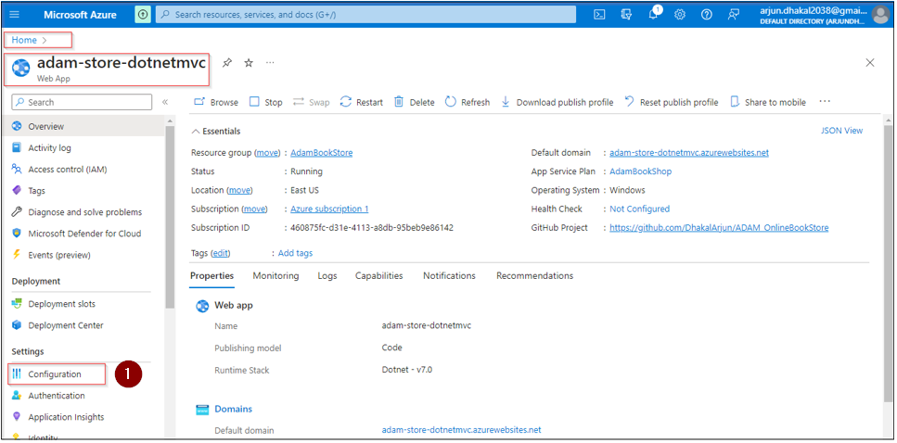

Then click on "+ New application setting", then provide the setting name and provide value as "Production" declaring that as environment appsetting.Production.json to be used.

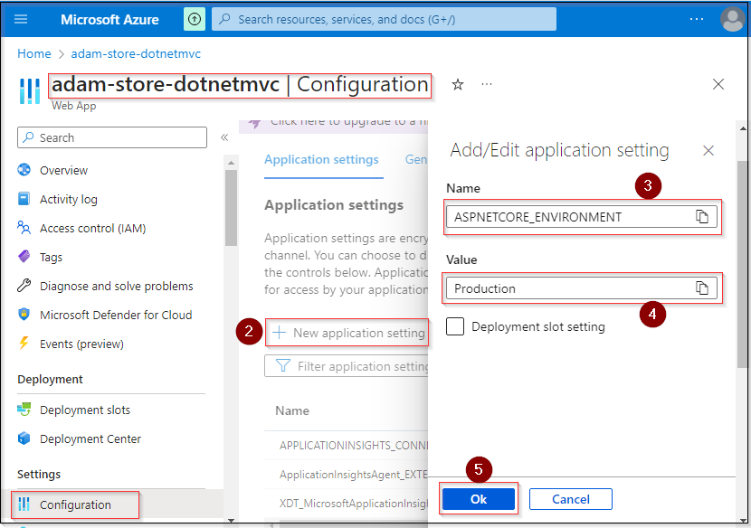

Finally click "OK" to save change.

### 14.3.6 Replace Hardcoded URL

Till now application look working well but when one try to place order during payment via Stripe, we will get error as we hard coded URL <https://localhost:7169/> for our application. Here we basically must get this URL more dynamically as shown in snippets below.

We have hardcoded URL in two places, fist on domain - /cart/summary/.

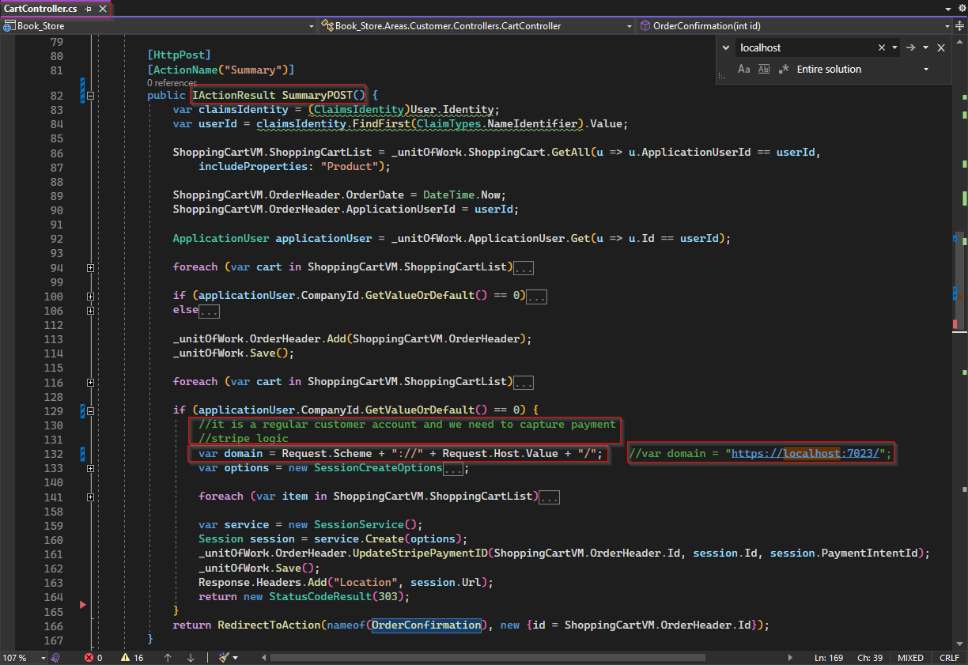

Next on - /order/details/

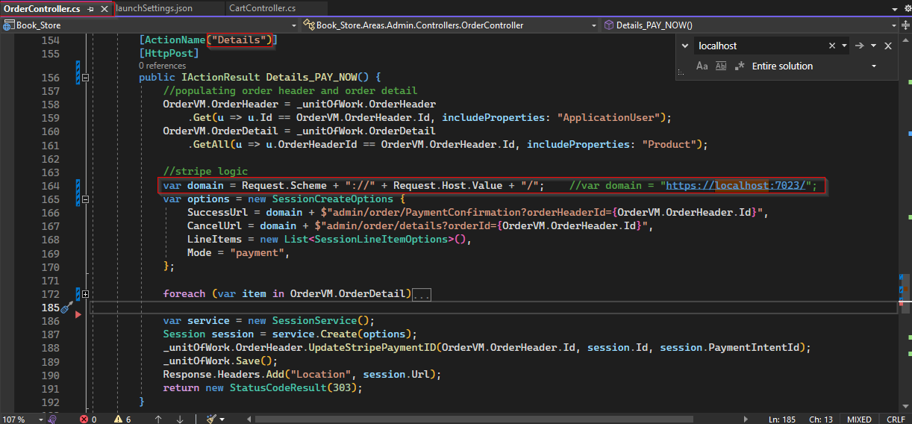

Once edit completed, push the change to Github and wait the new change redeployed.

On the deployed application, the is another similar issue due to new URL. When one try to register using Facebook, it will not work anymore due the URL we have provided while setting up Facebook Login.

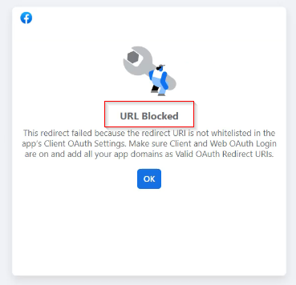

To resolve this issue, we need to <https://developers.facebook.com/> and add new URI to input field for Valid OAuth Redirect URIs and save change as follows.

